

## Department of Production Engineering (Sandwich)

AN

IN-PLANT TRAINING REPORT AT

# Lok Nayak Jayprakash Narayan Sahakari Soot Girni Ltd.

SUBMITTED BY

URVESH PATIL (SEAT NO. B150217553)

UNDER THE GUIDANCE OF Prof. Y R CHANDWADE

(YEAR 2020-2021)

AISSMS COE PUNE, PRODUCTION (S/W) ENGINEERING



## Department of Production Engineering (Sandwich)

***CERTIFICATE***

This is to certify that the In-plant training Report entitled

# Assignments Name

Spare Parts Management

Pulley Manufacturing on Lathe Machine

Packaging Quality Control Checklists

Submitted by

MR. URVESH PATIL SEAT NO. B150217553

Is a Bonafide work carried out under the supervision and guidance of Prof. Y R Chandwade and it is approved for the partial fulfillment of the requirements of Savitribai Phule Pune University, for the award of the Degree of Bachelor of Engineering (Production Sandwich). The In- plant training report has not been earlier submitted to any other Institute or University for the award of any Degree or Diploma.

|  |  |
| --- | --- |
| (Prof. Y R Chandwade) Guide,  Production Engineering Department | (Prof. S H Wankhade)  Head,  Production Engineering Department |
| (External Examiner) | |

Place: Pune Date:

AISSMS COE PUNE, PRODUCTION (S/W) ENGINEERING

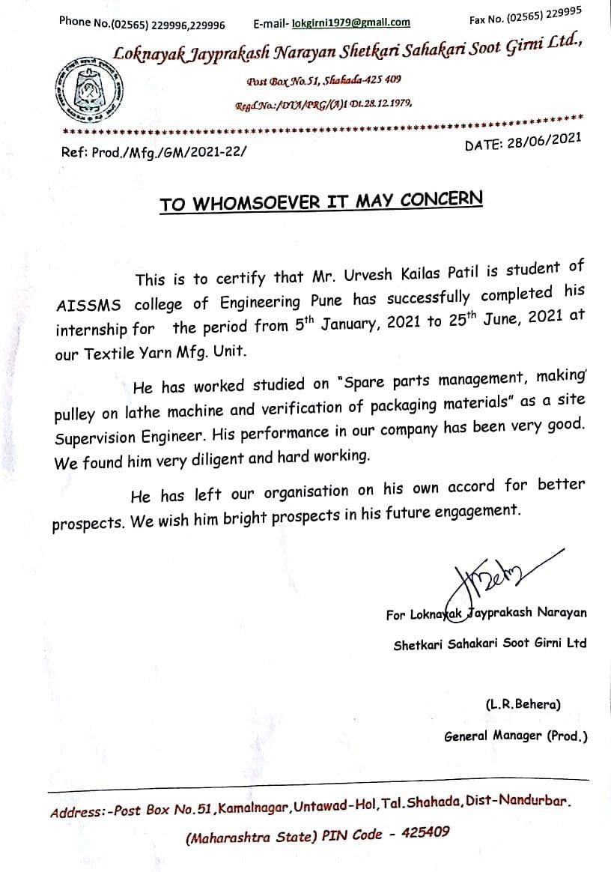

AISSMS COE PUNE, PRODUCTION (S/W) ENGINEERING

ACKNOWLEDGEMENT

I am deeply indebted to our In-plant Training Guide, Prof. Y R Chandwade, for his valuable Suggestions, Scholarly guidance, constructive criticism and constant encouragement at every step of the In-Plant training.

I also, would like to express our deepest gratitude to Prof. S H Wankhade, Head of Production Engineering Department and Dr. D. S. Bormane, Principal, AISSMS College of Engineering for granting the permission to choose this undertaking.

I wish to thank Mr. Bharat Patil (Sr. Manager) for constant guidance, co-operation, inspiration and practical approach, which provided me the much-needed impetus to work hard. I also thank all other persons who directly and indirectly contributed in successful completion of In-plant training.

My gratitude is also towards the management of Lok Nayak Jayprakash Narayan Sahakari Soot Girni Ltd. Shahada, for giving me opportunity to work in their esteemed organization.

MR. URVESH KAILASH PATIL

EMAILID: [patilurvesh11@gmail.com](mailto:patilurvesh11@gmail.com) MOBILE NO.: 7083536523

AISSMS COE PUNE, PRODUCTION (S/W) ENGINEERING

# CONTENTS

|  |  |  |  |
| --- | --- | --- | --- |
| SR. NO. | | TITLE | PAGE NO. |
| 1 |  | Title sheet | i |
| 2 |  | College Certificate | ii |
| 3 |  | Industry Certificate | iii |
| 4 |  | Acknowledgement | iv |
| 5 |  | List of Figures | vi |
| 6 |  | Abstract | viii |
| 7 |  | INTRODUCTION TO THE COMPANY | 1 |
| 8 |  | ASSIGNMENT NO. 1  SPARE PARTS MANAGEMENTS | 11 |
| 9 |  | ASSIGNMENT NO. 2  PULLEY MANUFACTURING ON LATHE MACHINE | 22 |
| 10 |  | ASSIGNMENT NO. 3  PACKAGING QUALITY CONTROL CHECKLISTS | 33 |
| 11 |  | CONCLUSION | 49 |
| 12 |  | REFERENCES | 50 |

AISSMS COE PUNE, PRODUCTION (S/W) ENGINEERING

**List of Figures**

|  |  |  |
| --- | --- | --- |
| **Figures No.** | **Figures Names** | **Page No.** |
| 1.1 | Cotton Yarn | 4 |
| 1.2 | Raw Cotton | 5 |
| 1.3 | Blow Room | 6 |
| 1.4 | Carding Machine | 7 |
| 1.5 | Spinning Machine | 8 |
| 1.6 | Comber Machine | 8 |
| 1.7 | Lap Former | 9 |
| 2.1 | List of Requistion | 14 |
| 2.2 | Bin Card | 14 |
| 2.3 | List of Receiving Parts | 20 |
| 3.1 | Single groove v-belt pulley | 24 |
| 3.2 | Double groove v-belt | 24 |
| 3.3 | Dimension of pulley | 26 |
| 3.4 | Lathe Machine | 27 |
| 3.5 | Tools | 29 |
| 3.6 | Micrometer | 30 |
| 3.7 | Thread Charts | 30 |
| 3.8 | Ginning Machine | 31 |
| 4.1 | Corrugated | 35 |
| 4.2 | Flutes | 36 |
| 4.3 | Combined Board | 37 |
| 4.4 | Stretch Wrap | 38 |

AISSMS COE PUNE, PRODUCTION (S/W) ENGINEERING

|  |  |  |
| --- | --- | --- |
| **Figures No.** | **Figures Names** | **Pages No.** |
| 4.5 | Corrugated Box | 39 |
| 4.6 | Ultra Violet Room | 39 |
| 4.7 | Palletized | 40 |

AISSMS COE PUNE, PRODUCTION (S/W) ENGINEERING

**Abstract**

In the competitive markets, the spinning mills must accomplish a superior relative value of yarns by means of quality and price. Assuring customer satisfaction for a long-lasting supply implies quality management with included advanced measuring systems.

The contribution is focused on highlighting of the importance of maintenance processes, particularly spare parts management in the industry.

The lathe is a machine tool which is used for producing components that are symmetrical about an axis. The accuracy of the work done on a lathe depends on the skill and experience of the operator.

Packaging has a significant impact on the efficiency and effectiveness of retail supply chain, where improvement can be achieved through the adaptation and development of the concept of packaging logistics.

AISSMS COE PUNE, PRODUCTION (S/W) ENGINEERING

## 

## Chapter No. 1

## Introduction to the Company

1. **Introduction:**

Incepted in the year 1979, Lok Nayak Jayaprakash Naryan Sahakari Soot Girni Ltd. (LJNSSGL) has carved a niche in the competitive yarn manufacturing industry by manufacturing and supplying quality yarn material. Initially LJNSSGL was commissioned in the year 1985-86 with 9576 spindles. They progressively increased the spindles capacity to 33660 spindles. Moving forward LJNSSGL has also established a new unit for the capacity of 24480 Spindles with State of Art machineries from Rieter Spinning System and Oerlikon Autoconers. Today the total Installed Capacity of Mills is 58140 Spdls with a Production Capacity of 38MT/Day or 1140 MT / Month.

Its expertise and success in the industry is an outcome of our strict adherence to uncompromising quality standards and a determination to offer our clients with the high level of satisfaction. Our product array includes some of the highly reliable yarn products that are globally known for their finest quality, competitiveness and durability in garmenting. With functional reliability, the mill is well equipped with machineries in their pursuit of quality excellence.

Under the able leadership of our mentor, Late Annasaheb P. K. Patil, founder chairman LJNSSGL has geared to leave their footprints through technologically advanced & clientele satisfaction. The success of LJNSSGL is attributed to sheer business acumen and professional expertise of personnel involved in all levels of the production.

## Machinery Maintenance:

A well-qualified & experienced team of machine maintenance staff take cares of all machineries & equipment’s through well planned preventive maintenance activities and followed the schedules as suggested by machine manufactures.

AISSMS COE PUNE, PRODUCTION (S/W) ENGINEERING

Moreover, mill is equipped with all the necessary maintenance tools & instruments required for in-house maintenance activity.

All maintenance fitters are well trained in their work and mill has arranged training program in house or outside as required for them.

## Quality Assurance:

A Planned and systematic pattern of all actions necessary to provide adequate confidence that the Product optimally fulfils customers’ expectations, i.e. it is problem free and well able to perform the task it was designed for.

LJNSSGL in-house quality control department is well installed with sophisticated and advanced technology-based quality testing equipment. This enables their yarn produced undergo rigorous quality tests on well-defined parameters to ensure maximum benefits of the clients as under:

* Their interactions and sequence.
* Defining the objectives of each process.
* Identify the key results area and measures the results.
* Establishing the procedures for getting required results.
* Educating the people to implement the right procedures.
* Preparing SOP to guide the people on work spot.
* Monitoring & measuring the performance.
* Concentrates on identifying various processes.
* Taking suitable actions on deviations and continuously improving the systems.
* Team continuously monitor & measure the input and output of each process and product quality to achieve the desired results and whenever it deviates it segregated as non-confirm product and allowed to go with fresh material.

AISSMS COE PUNE, PRODUCTION (S/W) ENGINEERING

## 

## Vision and Mission:

Our mission is to offer total customer satisfaction and achieve leadership in markets, providing value added services to our clients and assuring the quality and integrity keeping clear focus on speed, efficiency and quality and hence we are completely set and sound to take comprehensive challenges of future.

AISSMS COE PUNE, PRODUCTION (S/W) ENGINEERING

**Chapter No. 2**

**Products**

## 2.Cotton Yarn: -

Now-a-days cotton cloths are preferred over synthetic fabric because it is environment friendly and comfortable to wear. The same way, we are also reckoned as the prime Manufacturer, Exporter and Supplier of Organic Cotton Yarn in India, under the brand name JAY SOOT". Our Cotton Yarn is available in 20 to 60 types of variety, suitable for diverse industrial applications.

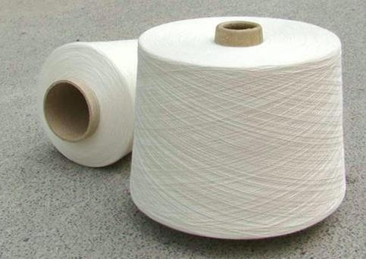

Figure 1.1 Cotton Yarn

## Demanded By

* Power loom
* Cloth manufacturers

## Attributes

* Moisture less
* Soft
* High absorption power
* Finely processes

AISSMS COE PUNE, PRODUCTION (S/W) ENGINEERING

## 

## Raw Cotton: -

The company is known as the major Manufacturer, Exporter and Supplier of the premium Raw Cotton in India. Our Raw Cotton is carefully processed by the expert professionals, with the help of latest technology. Furthermore, our Raw Cotton is offered at the market

leading prices to the global clients.

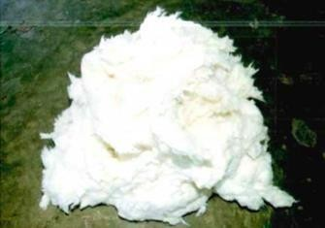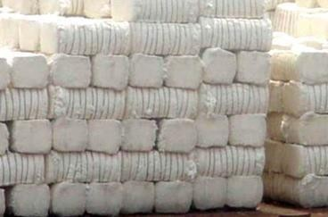

Figure 1.2 Raw Cotton

## Attributes

* Moisture less
* Soft
* High absorption power
* Finely processed
* 100% pure
* Fine quality

## Applications

* Apparel industry
* Textile industry
* Clothes manufacturing industries

AISSMS COE PUNE, PRODUCTION (S/W) ENGINEERING

## Chapter No.3

**Technology**

The Plant & Machinery required for the Spinning Mill process for manufacturing yarn of different counts are blow room machinery, metal detection system, sparks diversion system, carding machines, card accessories, draw frame (Finisher & Breaker), speed frame, combers, ring frame, electrical infrastructure, yarn testing instruments, humidification and waste collection system and automatic cone winding machine etc.

## Types Of Machinery:

1. **Blow room**

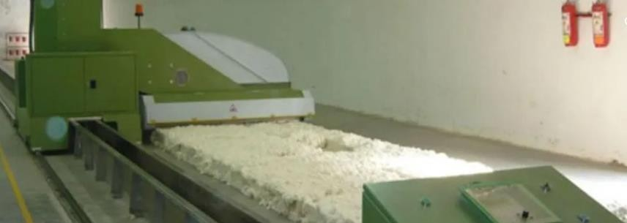

Figure 1.3 Blow Room

Blow room is the initial stage in spinning process. The name blow room is given because of the "air flow" And all process is done in blow room because of air flow. Blow room is consisting of different machines to carry out the objectives of blow room. In blow room the tuft size of cotton becomes smaller and smaller.

AISSMS COE PUNE, PRODUCTION (S/W) ENGINEERING

In a word we can say a section in which the supplied compressed bales are opened, cleaned & blending or mixing to form uniform lap of specific length is called Blow room section.

## Carding Machine:

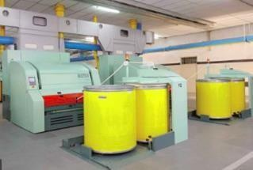

Figure 1.4 Carding Machine

Carding fulfils a series of precise objectives, serving: To remove impurities, blend the raw material further, reduce the blend to a web of fibers and to divide it up into rovings of the required count, suitable for feeding to the spinning machines

AISSMS COE PUNE, PRODUCTION (S/W) ENGINEERING

## Spinning Machine:

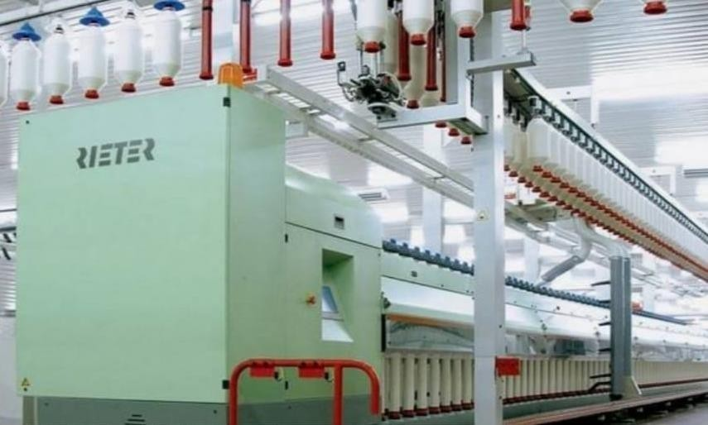

Figure 1.5 Spinning Machine

Cotton-spinning machinery refers to machines which process prepared cotton roving into workable yarn or thread. A process of making yarn from fibers. In this process a mass of cotton wool fibers are drawn out and twisted. It is an art where the fiber is drawn out, twisted, and then wound onto a bobbin. By this, fiberscome together to form a yarn.

The system consisting of spinning ring, ring holder, and support ring is a cost- optimized solution for ring spinning machines, the company reports. It is said to allow increased speed and thereby a higher production.

## Comber Machinery:

Figure 1.6 Comber Machine

AISSMS COE PUNE, PRODUCTION (S/W) ENGINEERING

To improve the yarn quality, the comber must perform the following operations:

* + Elimination of precisely pre-determined quantity of short fibers;
  + Elimination of the remaining impurities;
  + Elimination of a large proportion (not all) of the naps in the fiber material;
  + Formation of a sliver having maximum possible evenness;
  + Producing of more straight and parallel fibers.

## Lap Former:

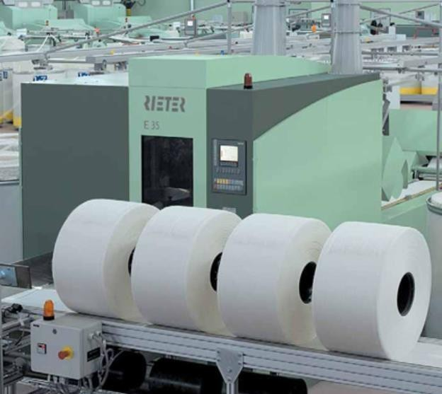

Figure 1.7 Lap Former

## Tasks of a Lap Former

* + Diminishing the irregularities such as – thick and thin places.
  + Producing regular and even lap for comber machine.
  + Declining the fiber damage throughout the processing.
  + Parallelizing and straightening the fibers in laps.
  + Lessening the chances of upright fibers waste.

Yarns which are made up of longer length of fibers, tend to show less irregularities in subsequent processes. Those yarns are superior in quality and carry lower percentage of hairiness as well.

AISSMS COE PUNE, PRODUCTION (S/W) ENGINEERING

A comber machine provides us such uniform and regular slivers that are free from a predetermined length of short fibers. So, basically for manufacturing such [types](https://textiletuts.com/yarn-types/) [of greater quality yarn,](https://textiletuts.com/yarn-types/) use of a comber machine is a must in our spinning line.

But before we start to manufacture these uniform slivers in comber which ultimately lead us to craft extra-ordinary yarn, we need to produce a number of uniform laps as well. To produce those laps, there the lap formers come into action.

AISSMS COE PUNE, PRODUCTION (S/W) ENGINEERING

**ASSIGNMENT No.1**

**Introduction:**

# SPARE PARTS MANAGEMENT

Spare parts Management plays an important role in achieving the desired plant availability at an optimum cost. It has been observed in many industries that the non-availability of spare parts, as and when required for repairs. It is a paradox to note that the maintenance department is complaining of the non-availability of the spare parts to meet their requirement and finance department is facing the problem of increasing locked up capital in spare parts inventory. This amply signifies the vital importance of spare parts management in any organization.

The unique problems faced by the organization in controlling or managing the spare parts are Firstly, there is an element of uncertainty as to when a part is required and also the quantity of its requirement. Secondly, spare parts are not that easily available in the market as they are not fast-moving items. There is a tendency from the stage of purchase of the equipment to the stage of the use of the spare parts, to requisition spare parts more number than that are actually required and accumulation of spares takes place. Finally, the rate of consumption of spare parts for some are very high and for some are very low. These problems are to be faced by systematic spare parts management.

The objective of spare parts management is to ensure the availability of spares for maintenance and repairs of the plant and machinery as and when required at an optimum cost. Also, the spares should be of right quality. There are many actions required to ensure the spare parts management effective. For the spare parts which are very expensive and those which are to be imported, it is essential that the useful life for such spares is extended by appropriate applications of reconditioning and repair techniques.

AISSMS COE PUNE, PRODUCTION (S/W) ENGINEERING

the application of computers for the processing of spare parts information and operating an effective spare parts control system will be very helpful for the organization and will ensure timely actions for an efficient and effective spare parts management.

## Spare parts management system:

A spares management process is a system between a company and a spare parts supplier to provide a direct way to inventory and ship spares before you need them.

## Bill of Materials:

A bill of materials (BOM) is a comprehensive inventory of the raw materials, assemblies, subassemblies, parts and components, as well as the quantities of each.

## Source of Stockout:

It is impossible to eliminate the issue of stockout (out of stock parts) without investing in spares. However, if you try to identify the major cause(s) of your stockout you can limit the effects it has on your operation. Start recording the reason(s) for out-of-stock parts in real time. Additionally, review forecasted demand and look for parts that may have an incorrect order setting. It should be noted that the most typical cause for stockout is the delay that may exist within a supply chain.

## Operating Strategy:

Predictive management of spare parts includes the collection and analysis of data, and the ability to look at the entire scope of operation to locate and solve important underlying problems that may surface in the long run. In relation to collecting and analyzing data, be sure to look out for patterns of failure that can reveal problems that are not clearly visible. Predictive management will help you to make better use of resources, cutting the time and cost associated with fixing issues.

AISSMS COE PUNE, PRODUCTION (S/W) ENGINEERING

## 

## Lead Times:

Having a thorough understanding of spare part lead times is critical to building a successful stock program. Part lead time is particularly important when determining which parts to stock. If downtime is not critical for company, parts that can be acquired quickly and easily can be left out of a stocking plan. Many parts with long lead times are made to order and do not carry expediting options.

## Identification of spare parts:

When a spare part is required to put back in operation an equipment which is under breakdown, it becomes necessary to identify the part for getting the same issued from the store or for purchasing the same from the vendor. While identifying it becomes essential to give the complete description including the size and type of the spare to draw from the stores and it becomes essential for all concerned i.e., the maintenance personnel and stores personnel are aware of such description. If it is the vendor, he may not be satisfied with the description and he may also require the manufacturer's part number.

It is a cumbersome and time-consuming task during every transaction to identify a spare part by its description and manufacturer's part number accompanied by the parent equipment's name, make and model designation. Therefore, it is essential to give a numerical name or code to each spare part.

This process of giving code to each spare part is called codification. Since, the range of spares used in any organization is too large and there are quite a few spares meant for specific equipment, it is always preferred to use codes which are significant ie., from the code number one will be able to find out Codification also helps easy accounting and computerization in addition to easier communication between concerned parties.

In addition to codifying the spare part, it will be of immense benefit to codify the location of spare parts.

AISSMS COE PUNE, PRODUCTION (S/W) ENGINEERING

Stock location number helps the stores personnel to locate the part and issue the same as and when the same is requisitioned. Also, the stock verification and upkeep program me becomes less and less cumbersome.

After codifying the spare parts and assigning stock location numbers, all the users should be made aware of and should be supplied with the relevant codes and stock location numbers in the form of a spare parts catalogue.

## Lists of Material Requistion book:

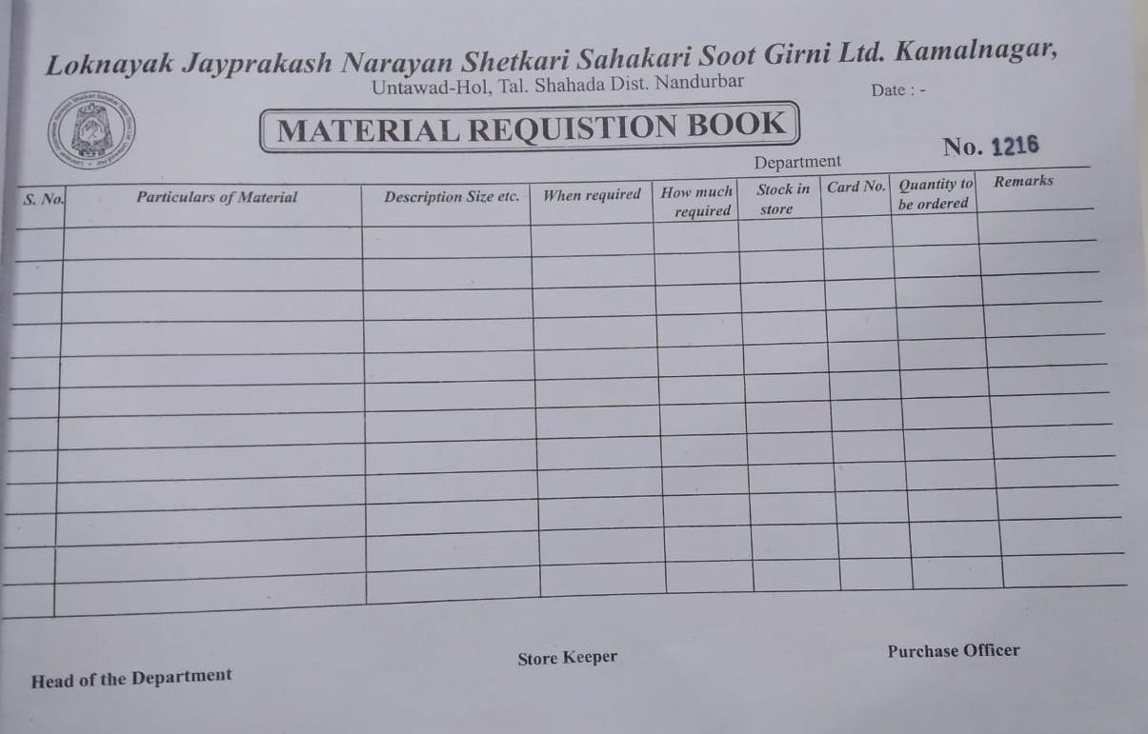

Figure 2.1 List of Requistion

## Bin Card:

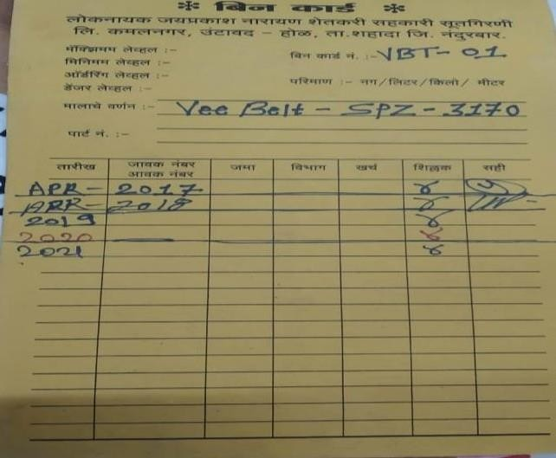

Figure 2.2 Bin Card

## AISSMS COE PUNE, PRODUCTION (S/W) ENGINEERING

## The spare parts catalogue should contain the following information:

Spare parts codification plan. Spare part code.

Spare part description. Drawing number.

Manufacturer's code & part number. Stock location number.

The next step in identification of spare parts is to put an identification tag or mark with the code to enable the stores personnel identify during the time of issue. If sufficient care is not taken to incorporate the code, a lot of time is spent in locating the part and that time is actually added to the down-time which is really very expensive in case of vital spare parts. There are a variety of stickers which are scratch-proof, water-proof and temperature-proof available in the market.

## Analysis and selective control:

For the successful spare parts management, it is essential to analyze the spare parts inventory based on various characteristics such as the frequency of issues, the annual consumption value, the criticality, the lead time and the unit price. This is essential as it would not be possible to exercise the same type of control for all items and it may not really be effective. Inventory analysis aids selection of policies for selective control.

Commonly used inventory analyses are:

## FSN Analysis: (Fast moving, slow moving and Nonmoving):

Classification based on Frequency of Issues/Use: -

F, S & N stand for Fast moving, slow moving and Nonmoving items. This form of classification identifies the items frequently issued, less frequently issued for use and the items which are not issued for longer period, say, 2 years. For instance, the items can be classified as follows.

AISSMS COE PUNE, PRODUCTION (S/W) ENGINEERING

Fast Moving (F) = Items that are frequently issued say more than once a month. Slow Moving (S) = Items that are issued less than once a month.

Non-Moving (N) = Items that are not issued\used for more than 2 years.

This classification helps spare parts management in establishing most suitable stores layout by locating all the fast-moving items near the dispensing window to reduce the handling efforts. Also, attention of the management is focused on the Non-Moving items to enable decision as to whether they are required in the future or they can be salvaged.

## SDE Analysis: (Scarce, Difficult, Easily available):

This classification is carried out based on the lead time required to procure the spare part. The classification is as follows:

Scarce (S): Items which are imported and those items which require more than 6 months' lead time.

Difficult (D): Items which require more than a fortnight but less than 6 months' lead time.

Easily available (E): Items which are easily available ie., less than a fortnights' lead time.

A comprehensive analysis may ultimately bring down lead time for more & more number of items. This will also result in streamlining the purchase and receiving systems and procedures.

## VED Analysis: (Vital, Essential, Desirable):

Several factors contribute to the criticality of a spare part. If a spare is for a machine on which many other processes depend, it could be of very vital importance. Also, if a spare is, say, an imported component for which procurement lead time could be very high its non- availability may mean a heavy loss.

Similarly spares required for fighter aircraft at the time of war could be of great value in terms of fighting capability. In general, criticality of a spare part can be determined from the production downtime loss, due to spare being not available when required

Based on criticality, spare parts are conventionally classified into three classes, Vital (V): A spare part will be termed vital, if on account of its non-availability there will be very high loss due to production downtime and/or a very high cost will be involved if the part is procured on emergency basis. In a process industry, most spare parts for the bottleneck machine or process will be of vital nature. For example, bearings for a kiln in a cement plant will be considered vital.

Essential (E) : A spare part will be considered essential if, due to its non- availability, moderate loss is incurred. For example, bearings for motors of auxiliary pumps will be classified as essential.

Desirable (D): A spare part will be desirable if the production loss is not very significant due to its non-availability. Most of the parts will fall under this category. For example, gaskets for piping connection.

The VED analysis helps in focusing the attention of the management on vital items and ensuring their availability by frequent review and reporting. Thus, the downtime losses could be minimized to a considerable extent.

## ABC Analysis: -

Classification Based on Consumption:

Another method of classifying spares is on the basis of annual consumption value. As it is true for any inventory situation, Pareto's principle can be applied to classify maintenance spares based on consumption value.

Pareto principle: The significant items in a given group normally constitute a small portion of the total items in a group and the majority of the items in the total will, in aggregate, be of minor significance.

AISSMS COE PUNE, PRODUCTION (S/W) ENGINEERING

Class A: 10% of total spares contributing towards 70% of total consumption value. Class B: 20% of total spares which account for about 20% of total consumption value.

Class C: 70% of total spares which account for only 10% of total consumption value

## HML Analysis:(High Cost, Medium cost, Low cast):

Classification based on unit price:

High Cost (H): Item whose unit value is very high, Rs.1000/- and above. Medium Cost (M): Item whose unit value is of medium value, above Rs.100/- but less than Rs.1000/-.

Low Cost (L): Item whose unit value is low, less than Rs.100/-.

This type of analysis helps in exercising control at the shop floor level ie, at the use point. Proper authorization should be there for replacing a high value spare. Efforts may be necessary to find out the means for prolonging the life of high value parts through reconditioning and repair. Also, it may be worthwhile to apply the techniques of value analysis to find out a less expensive substitute

## Inventory control system:

To ensure smooth functioning it is essential to develop a suitable inventory control by which optimization of spare parts cost is achieved in a systematic way. As regards the fast moving and slow-moving items are concerned, the following procedure can be followed taking into consideration various cost elements.

While managing the spare-parts inventory, basically there are four cost elements to be considered:

1. Cost of spare of spare parts.
2. Cost of ordering.
3. Cost of storage.
4. Cost of stock out.

AISSMS COE PUNE, PRODUCTION (S/W) ENGINEERING

## Insurance Spares:

An insurance items is a spare part that will be used to replace a failed identical part in an operating equipment whose penalty cost for downtime is very high. Hence, by definition, it is an insurance against such failures for which the down time costs are very high. They do not become obsolete until the parent equipment is retired from service no matter if they do not move for many years.

## Overhaul spares:

Spare parts which must be replaced every time the equipment is dissembled and re- assembled.

## Receiving:

At this stage, the materials and parts are received from different suppliers and unloaded. The parts received at this stage are scanned and ownership is taken. Both the quality and quantity are checked.

## Purchasing:

Purchasing describes the process of buying. It is the learning of the requirement, identifying and selecting a supplier, negotiation price. Purchasing is an element of the wider function of procurement and it includes many activities such as ordering, expediting, receipt and payment. Purchasing is responsible for obtaining the materials, parts, supplies and services needed to produce of a product or provide a service. Purchasing can be divided into two broad categories, large and small purchases.

AISSMS COE PUNE, PRODUCTION (S/W) ENGINEERING

## List of Receiving parts from supplier:

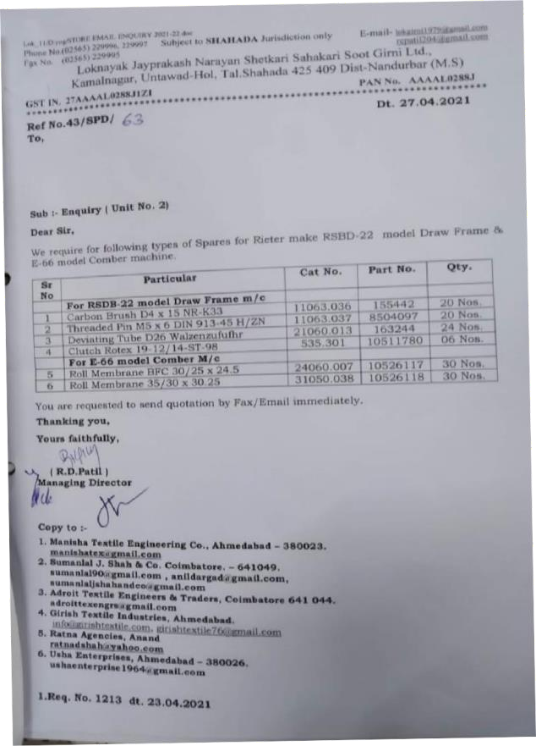

Figure 2.3 List of Receiving Parts

## There are five rights that every management expects from their purchasing executives:

Right Quantity Right Quality Right Time Right Supplier Right Cost

AISSMS COE PUNE, PRODUCTION (S/W) ENGINEERING

## Store Maintenance:

It includes all the activities involved in managing store’s facilities such as management of exterior and interior physical facilities.

The exterior facilities include the parking arrangement, the entrances to the store, loading and unloading area of the store etc.

Interior facilities include the arrangement for racks, walls, flooring, ceiling, climate control, energy use, fixtures and shelves, displays and signs and sidewalks etc.

Good store maintenance lengthens the useful life of air conditioning units, floors, electric equipment, fixtures.

AISSMS COE PUNE, PRODUCTION (S/W) ENGINEERING

**ASSIGNMENT NO. 2**

**PULLEY MANUFACTURING ON LATHE MACHINE**

## Introduction:

**Pulley:**

A pulley is a wheel that carries a flexible rope, cord, cable, chain, or belt on its rim. Pulleys are used singly or in combination to transmit energy and motion. Pulleys with grooved rims are called sheaves. In [belt drive,](https://www.britannica.com/technology/belt-drive) pulleys are affixed to shafts at their axes, and power is transmitted between the shafts by means of endless belts running over the pulleys.

How well a V-belt fits into the pulley determines how much power the belt drive can transmit and how efficiently it operates. Hence, use correct groove section and correct groove angle. It may be noted that the groove angle depends on the pitch diameter of the pulley. A well-engineered belt and a well-machined, matching pulley combination only will provide the most efficient drive operation.

It is recommended to select pulley diameter as large as possible considering its cost- effectiveness. Large pulley diameters have a positive effect on the service life of the V-belt. It is also essential that the recommended minimum pulley diameter is adhered to because pulley diameters below the recommended diameters affect the service life of the V-belt.

V-grooved pulleys are manufactured mainly from cast iron or from other materials to customer specifications in different constructions.

Machining of the face or periphery and of the bore shall be of fine finish and the sides of the grooves finished by a broad tool, so that no tool marks are visible and a polish is obtained. The top corners and bottom corners of all grooves shall be chamfered.

AISSMS COE PUNE, PRODUCTION (S/W) ENGINEERING

## Material use for pulley:

Pulleys can be made from a variety of materials, including cast iron, cast steel or pressed steel, wood, and paper. The cast material should have good friction and wear characteristics. The pulley made from pressed steel is lighter than cast pulleys, but in many cases, they have less friction and can produce excessive wear.

## Belt and pulley:

The device helps in power transmission using a cable or belt. In a belt and pulley system, a belt runs along a pulley's groove so that the power can be transfer either from one pulley to another or from the pulley directly to the application that requires power.

## Selection of pulley:

They are built under the following condition required: the speeds of and the power transmitted between drive and the driven unit, suitable distance between the shafts, and appropriate operating conditions.

## Advantage of pulley:

1. It provides mechanical advantage while lifting heavy loads.
2. Silent in operation.
3. At acts as a support for long distance moving ropes.
4. No lubrication required.

## Types of pulleys:

There are three main types of pulleys: fixed, movable, and compound. A fixed pulley's wheel and axle stay in one place.

AISSMS COE PUNE, PRODUCTION (S/W) ENGINEERING

## V Belt:

The v-belts are made of rubber with fabric cords to transmit power and its covered with a protective layer. The cords transmit the force from the driver to the driven pulley, thereby transmit the power. The number of cords are increased based on the force requirements. The rubber layer transmits the force in cord to the side layers.

V-belts are widely used in industry and automobiles because of its power transmitting capacity. the wedge shape of the belt increases the area of contact with the pulley there by increasing more friction which makes it ti carry more power without slip.

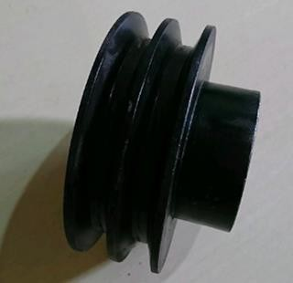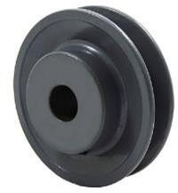

Fig 3.1 Single V belt pulley Fig 3.2 Double V belt pulley

**Lathe Machine:**

Introduction:

The main function of a lathe is to remove metal from a piece of work to give it the required shape and size. This is accomplished by holding the work securely and rigidly on the machine and then turning it against a cutting tool which will remove metal from the work in the form of chips.

AISSMS COE PUNE, PRODUCTION (S/W) ENGINEERING

## 

## Types of lathes:

Lathes are manufactured in a variety of types and sizes, from very small bench lathes used for precision work to huge lathes used for turning large steel shafts. But the principle of operation and function of all types of lathes is same.

1. Speed Lathe Machine
2. Engine Lathe Machines
3. Bench Lathe Machine
4. Toolroom Lathe Machine
5. Capstan and Turret Lathe Machine
6. Special purpose lathe machines
7. Automatic Lathe Machine

## Construction of Machine:

A simple lathe comprises of a bed made of grey cast iron on which headstock, tailstock, carriage and other components of lathe are mounted.

The major parts of lathe machine are given as under:

1. Bed
2. Head stock
3. Tailstock
4. Carriage
5. Feed mechanism
6. Thread cutting mechanism

## 

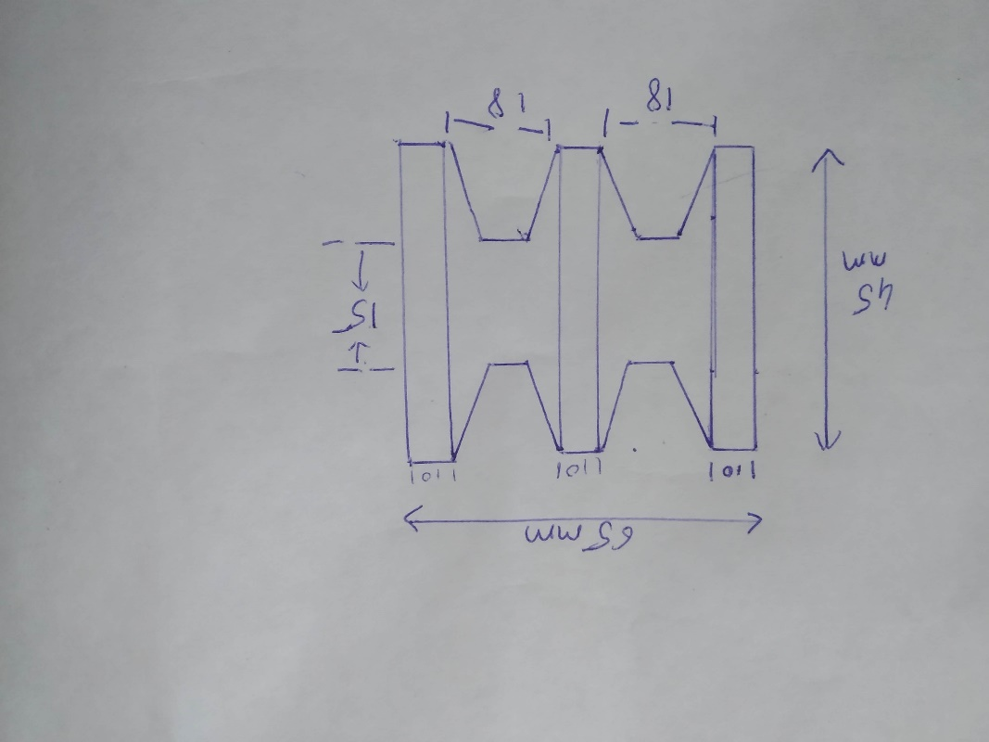

Fig 3.3 Dimension of pulley

**Process of pulley Manufacturing on lathe:**

Adjusting the workpiece into chuck.

Operation perform are:

1. Facing.
2. Turning.
3. Chamfer
4. Center drill
5. Drilling
6. Grooving
7. Taper turning
8. Polishing

AISSMS COE PUNE, PRODUCTION (S/W) ENGINEERING

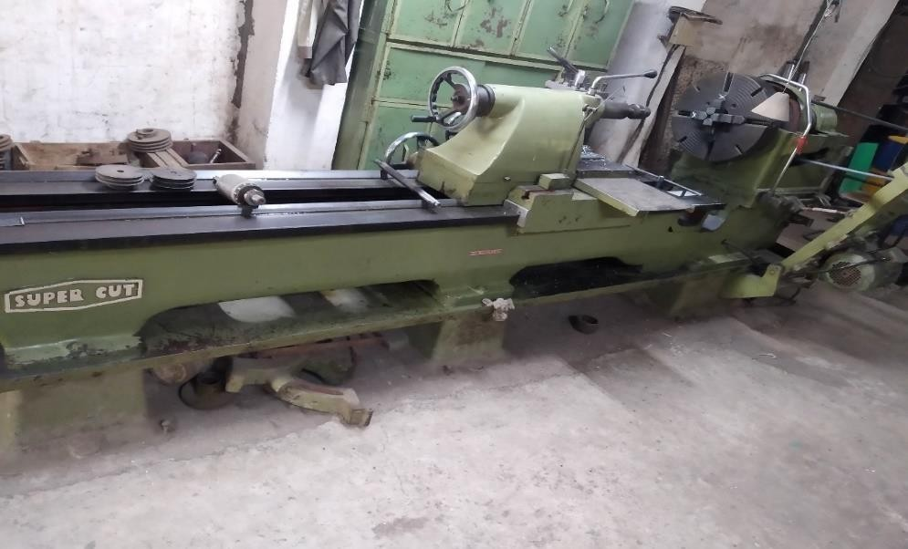

Figure 3.3 Lathe Machine

## Headstock:

It is located on the left-hand side of the lathe bed. It has a hollow spindle and the different types of mechanism for driving and changing the speed of the spindle. In this case, the speed increases when the belt is shifted from larger to smaller diameter pulleys.

## Tailstock:

The tailstock is located on the right-hand side of the lathe bed. The tailstock supports the other end of the workpiece when it is machining between two centres. It holds the tool rigidly and perfectly for performing operations such as drilling, reaming, tapping, and boring.

## Carriage:

The carriage is one of the most important parts of the lathe tool and it will serve as a supporting, moving, and controlling part of the cutting tools.

AISSMS COE PUNE, PRODUCTION (S/W) ENGINEERING

## Feed Mechanism:

Movement of the tool relative to the workpiece is termed as feed. Feed mechanism has different units through which motion is transmitted from headstock spindle to the carriage. Following units play role in feed mechanism of a lathe machine -

1. End of bed gearing 2. Feed gear box

3. Lead screw and feed rod 4. Apron mechanism

## Lathe Operation:

The general operations done with the lathe are grooving, turning, cutting, sanding and etc. Each lathe operation has got its own factors that need to be considered before doing the work. The factors should be used properly so that one can avoid from mishandling and mishaps while performing any kind of lathe operation. With every cut desired the speed, depth and feed of the lathe machine is changed for precision.

## Types of Lathe Operation:

**Facing:**

This is usually the first step of any lathe operation on the lathe machine. The metal is cut from the end to make it fit in the right angle of the axis and remove the marks.

## Tapering:

Tapering is to cut the metal to nearly a cone shape with the help of the compound slide. This is something in between the parallel turning and facing off.

## Parallel Turning:

This operation is adopted in order to cut the metal parallel to the axis. Parallel turning is done to decrease the diameter of the metal.

AISSMS COE PUNE, PRODUCTION (S/W) ENGINEERING

**Parting:**

For this the parting tool is involved in slowly to make perform the operation. For to make the cut deeper the parting tool is pulled out and transferred to the side for the cut and to prevent the tool from breaking.

## Tools:

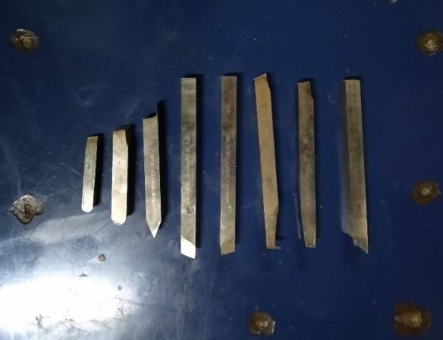

Figure 3.4 Tools

AISSMS COE PUNE, PRODUCTION (S/W) ENGINEERING

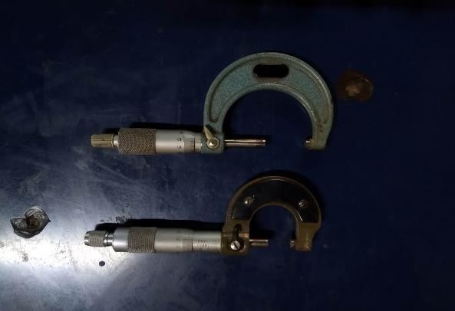

Figure 3.5 Micro meter

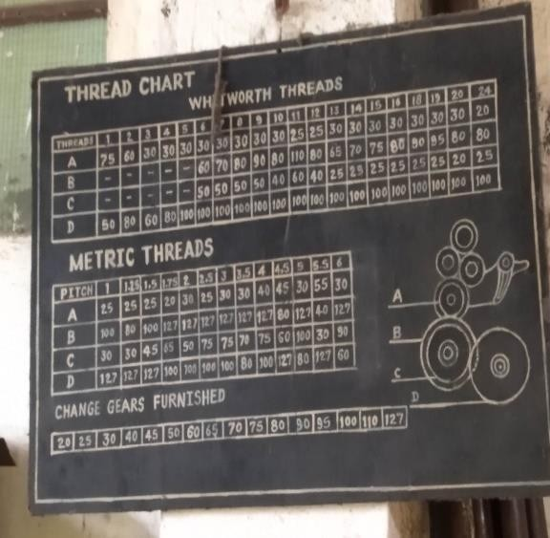

Figure 3.6 Thread Chart

AISSMS COE PUNE, PRODUCTION (S/W) ENGINEERING

## Ginning Machine:

Ginning is the first mechanical process involved in processing cotton. Is a machine that quickly and easily separates cotton fibers from their seeds, enabling much greater productivity than manual cotton separation. The primary function of a feeder is to feed seed cotton uniformly to the gin stand at controllable rates. The gin must also be equipped to remove foreign matter, control moisture and remove other contaminants that significantly reduce the value of the bale.

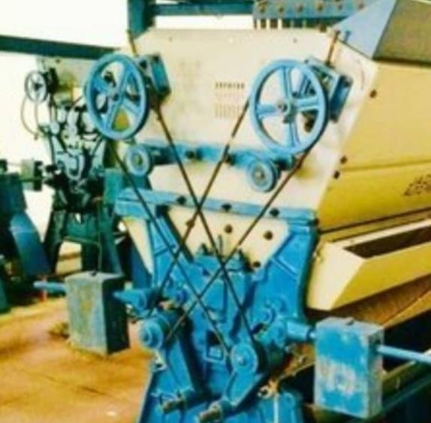

Figure 3.7 Ginning Machine

## It consists of following main component:

1. Main frame 7. Carding drum
2. Ginning roller 8. Wheel
3. Chain and sprocket 9. Pinion gear
4. Bearing 10. Pulley
5. Conveyor belt 11. v-belt
6. Gear 12. Hopper

AISSMS COE PUNE, PRODUCTION (S/W) ENGINEERING

## Objects of Ginning:

1. Make the fiber-free from seeds without gin-cut fiber.
2. Ensure the best quality of cotton and get the fair price of cotton in the market.
3. To be confident that fiber does not contain excess and unexpected seeds or a any other particles.
4. To make the spinning process easier and effective

AISSMS COE PUNE, PRODUCTION (S/W) ENGINEERING

# ASSIGNMENT NO. 3

# PACKAGING QUALITY CONTROL CHECKLIST

## 4. Introduction:

Product packaging serves to protect the product inside. Packaging must keep the product safe during shipment between the manufacturing facility and the retailer and must prevent damage while the product sits on the shelf. Packaging can be described as a coordinated system of preparing goods for transport, warehousing, logistics, sale, and end use. Packaging contains, protects, preserves, transports, informs, and sells, in many countries it is fully integrated into government, business, and institutional, industrial.

The primary purpose of packaging is to protect its contents from any damage that could happen during transport, handling and storage. Packaging retains the product intact throughout its logistics chain from manufacturer to the end user. It protects the product from humidity, light, heat and other external factors. Pallets are the primary interface of a unit load. They protect the product, absorb the stresses, hold the weight, encounter fork truck impacts, and safeguard goods traveling through the supply chain

## Requirements of Good Product Packaging:

It should be easy to handle. In case of products which shall not be turned upside down, the position should be clearly indicated like marking the size, shape and weight of the pack should be amendable for smooth handling. Further, it should also be indicated on the pack. up’.

It should be easy to identify the manufacturer from package. It should be adequately marked.

It should be easy to dispose of.

## Factors to be Considered for Package Designing in Product Packaging:

In packaging, designing is the most important element to be considered. In designing a package, the following factors should be considered:

## Language:

The language in which the package is printed should be the local one so that its contents call easily be read and understood by the consumers of the target market. If it is not so, the objective of package is itself lost and it will not perform the promotional function what is expected from it.

## Package Size:

The size of the package should be determined only on finding out the buying characteristics of the buyers. Size and frequency of consumption, storing capacity of consumers and the nature of product would be the probable factors to decide the buying characteristics. If the buyers shop the product regularly or they do not possess storing capacity such as freezers etc., the size of packages will have to be smaller.

## Container:

Some markets, especially developed countries, generally prefer disposable containers. Especially recently because of preoccupation regarding environmental pollution, the regulatory agencies sometimes insist that containers should be made of materials which will not have undesirable environmental effects. In the developing countries, however, reusable containers are preferred because of their storing utilities.

## Length of Distribution Channel:

Length of distribution channel, i.e., time taken between production and final consumption has an important bearing on deciding upon the packaging. The longer is the time, the greater is the necessity of providing better and stronger packaging.

AISSMS COE PUNE, PRODUCTION (S/W) ENGINEERING

## Climate:

Climatic conditions also affect the type of packaging. A country with a hot humid climate will have a different type of packaging, especially for eatables and perishable items, than what is required in a country having cold climate. The package must be made of materials which may protect the contents fromthe climate of the importing country.

## 

## Raw Material:

**Corrugated:**

Corrugated fiberboard or combined boar has two main components: the liner and the medium. Both are made of a special kind of heavy paper called containerboard. Linerboard is the flat material, typically on the outer surfaces of the board but also on the inside for some structures, that adheres to the medium. Medium is the paper that is formed into arches or flutes on the single facer and glue between the linerboard facings.

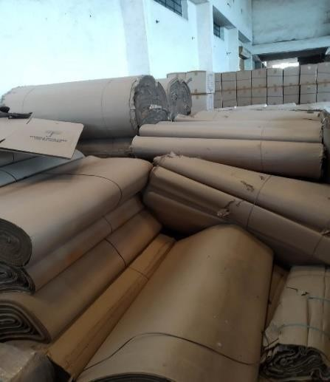

Figure 4.1 Corrugated

AISSMS COE PUNE, PRODUCTION (S/W) ENGINEERING

## 

## Checklists of Packaging:

## Verifying Quantities.

## Check Sealing, strapping and binding methods.

## Check shipping Markings and Barcodes.

## Check the condition of products and packaging.

## Checking the package weight.

## Flutes:

When a piece of combined board is placed on its end, the arches form rigid columns, capable of supporting a great deal of weight. The flutes act to keep the linerboard sheets separated, maximizing the bending rigidity of the board. When pressure is applied to the side of the board, the space in between the flutes acts as a cushion to protect the container's contents. The flutes also serve as an insulator, providing some product protection from sudden temperature changes. At the same time, the vertical linerboard provides additional strength and protects the flutes from damage.

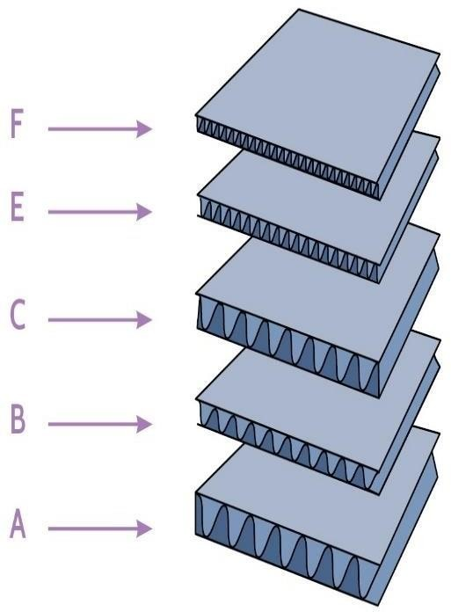

Figure 4.2 Flutes

AISSMS COE PUNE, PRODUCTION (S/W) ENGINEERING

A flute was the original flute profile for corrugated board.

B flute was then developed for canned goods that were self-supporting, and so did not require boxes that supported much load.

C flute was next developed as an all-purpose flute. E flute was the next successful flute profile.

F flute was developed for small folding carton type boxes.

## Combined Board:

The below illustration demonstrates four basic types of combined board that are most commonly created from linerboard and medium using the variety of flute structures:

Single Face: One corrugated medium is glued to one flat sheet of linerboard. Single Wall: The corrugated medium is glued between two sheets of linerboard. Also known as Double Face.

Double Wall: Three sheets of linerboard with two mediums in between. Triple Wall: Four sheets of linerboard with three mediums in between.



Figure 4.3 Combined board

AISSMS COE PUNE, PRODUCTION (S/W) ENGINEERING

## Pallet Stretch Wrapping Machine:

Stretch wrapping machines are used to wrap stretch film around a loaded pallet. Film provides extra support while the products are being transported & storage to protect them from tip, spill or from being damaged. Additionally, wrapped loads can easily be separated and identified. Stretch pallet wrapper is widely used in chemical industry. The most common stretch wrap material [linear low-density](https://en.wikipedia.org/wiki/Linear_low-density_polyethylene) [polyethylene.](https://en.wikipedia.org/wiki/Linear_low-density_polyethylene)

In [pallet](https://en.wikipedia.org/wiki/Pallet) unitizing, stretch wrap can have several functions:

* improved stability of products or packages, forming a [unit load.](https://en.wikipedia.org/wiki/Unit_load)
* more efficient handling and storage of unit loads.
* some degree of dust and moisture protection.
* some degree of [tamper resistance.](https://en.wikipedia.org/wiki/Tamper_resistance)
* some degree of sun protection (UV stretch wraps).

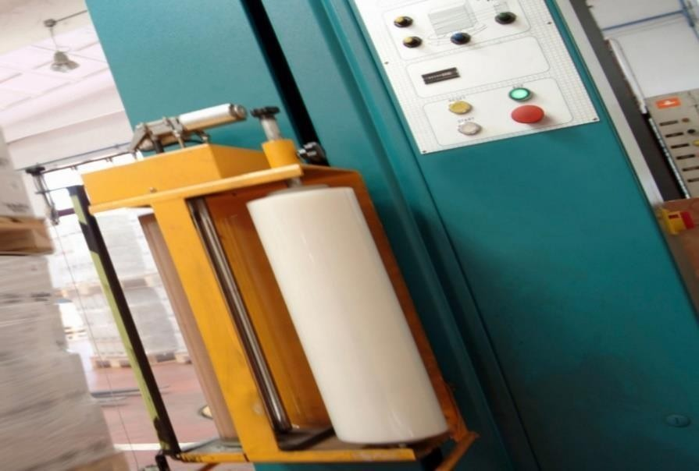

Figure 4.4 Stretch Wrap

AISSMS COE PUNE, PRODUCTION (S/W) ENGINEERING

## Corrugated Box:

Corrugated boxes are used frequently as [shipping containers.](https://en.wikipedia.org/wiki/Shipping_container) Boxes need to contain the product from manufacturing through distribution to sale and sometimes end- use. Boxes provide some measure of product protection.

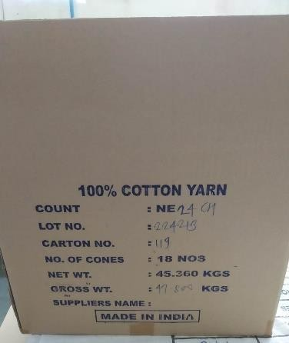

Figure 4.5 Corrugated Box

## Ultra-violet room:



Figure 4.6 Ultra violet room

AISSMS COE PUNE, PRODUCTION (S/W) ENGINEERING

## Palletization:

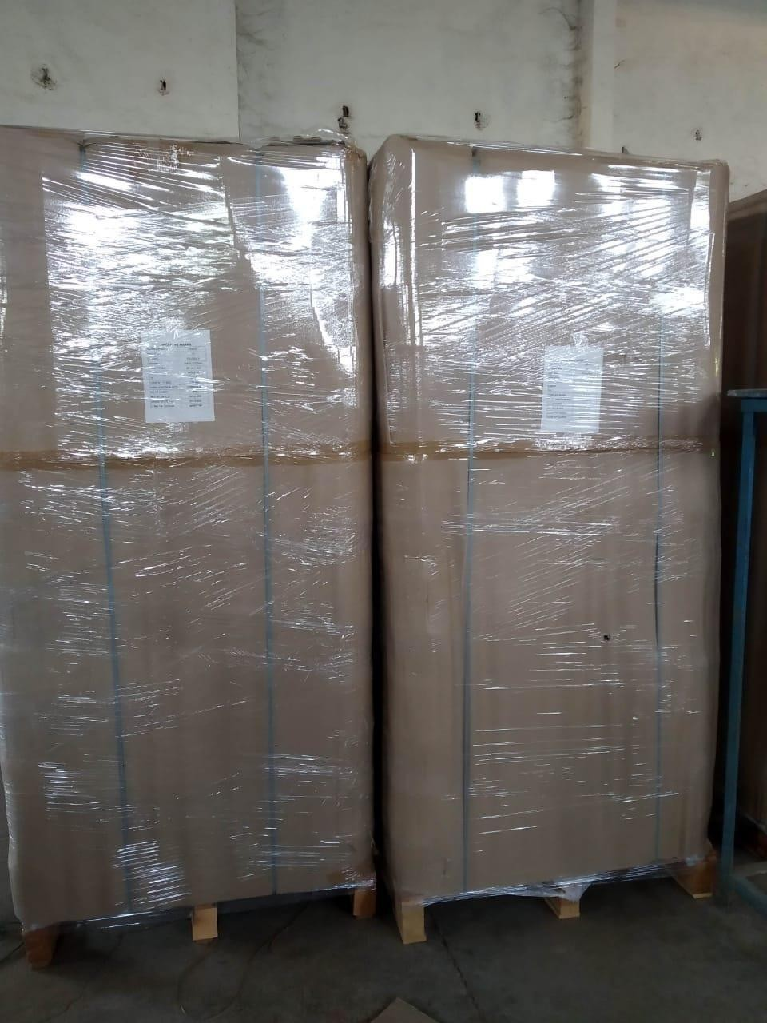

Figure 4.7 Palletized

Palletization refers to the process of placing goods or materials, either packaged, onto pallets. The pallet provides a base for the goods and materials, thereby promoting the efficient storage, handling and transport for the combination of goods and the pallet base, referred to collectively as the unit load.

AISSMS COE PUNE, PRODUCTION (S/W) ENGINEERING

## Conclusion:

I have worked on spare parts management in store of an industry. Spare part inventory management is very important as they are the responsibility of the organization.

A lathe machine is a heavy duty and high-powered tools largely used in engineering. There are different kinds of lathes used in engineering depending on what the job is.

Palletizing is the best-known method thus far to put together packages as one unit. This method makes handling goods safer, faster and more efficient.

AISSMS COE PUNE, PRODUCTION (S/W) ENGINEERING

## Reference:

1. Gopalakrishnan. P, Maintenance and spare parts management, Prentice Hall India learning private limited.
2. Dr. R. Kesevan, B. Vijaya Ramnath, Machine tool, University science press, 1st edition, 2010.
3. David. A. Henson, Jhon. S, Metal cutting Theory and Practices, CRC Press, Taylor & Francis group, 3rd edition, 2016.
4. DHL, Packaging guide right packaging for large & palletized goods, DHL Express Excellence.
5. Dansk group, Packaging instruction, 2016.
6. Confluence Denver, [Pallet Fest Upcycles Denver,](https://www.confluence-denver.com/features/palletfest_082615.aspx) published 2015. 7.Sigmathermal.com/blog/spare-parts-management/.
7. Opexworks.com/base/ Maintenance Management/Spare parts.
8. https://themechanicalengineering.com/lathe-machine/ 10.[http://freightfilter.com/packaging-guide.](http://freightfilter.com/packaging-guide)

AISSMS COE PUNE, PRODUCTION (S/W) ENGINEERING